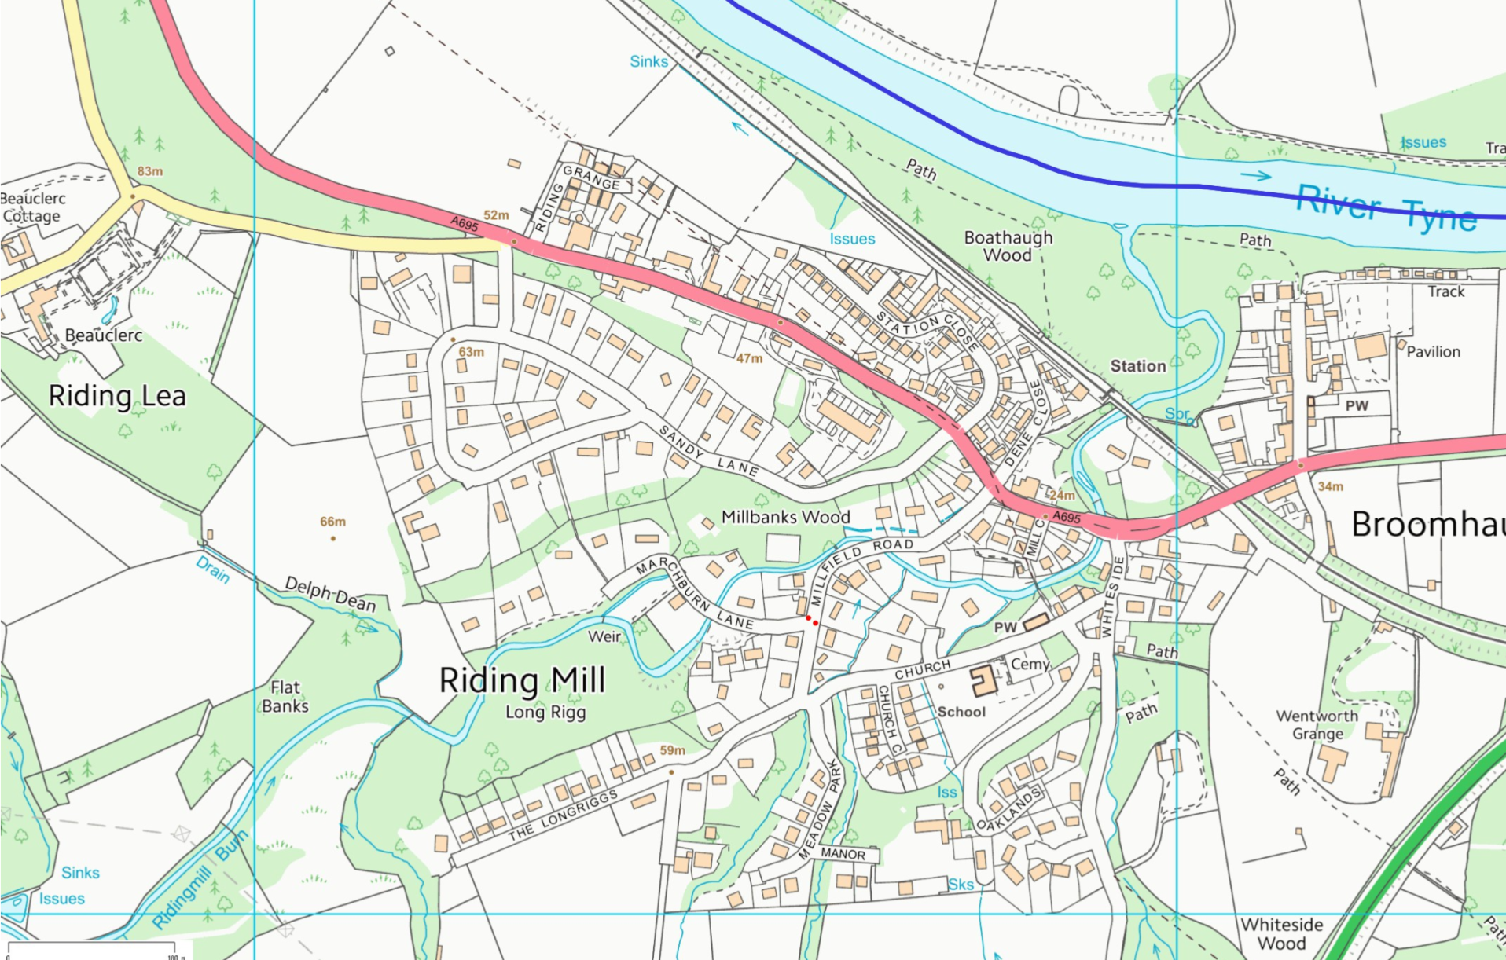

Wooden footbridge

Double tennis courts – parking area

Approach to station

The Nick

Play Park

Bridges

Spinney / Old Playground