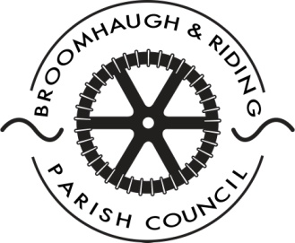
Broomhaugh & Riding Parish Council

Minutes of the extraordinary Council meeting held on Wednesday 24th May in the Supper Room, Parish Hall, Riding Mill.

Councillors present:
Cllr. Andy Dunhill (Chairman) Cllr. Brian Singer
Cllr. Malcolm Reid Cllr. Eileen Carew
Cllr. Jill Mills Cllr. Peter Howe

In attendance:
Mrs Catherine Harrison – Parish Clerk
Public: Mr R Archer

17/47 Apologies
Apologies were received from Cllr. David McKenzie.

17/48 Declaration of Interests
No disclosures of personal and prejudicial interests on matters to be considered at the meeting were given.

17/49 Repairs to March Burn riverbank
It was reported that the quote for the repairs to the riverbank adjacent to the double tennis courts had been received from River Catchment Services (RCS), the commercial arm of the Tyne Rivers Trust. A discussion was held as to whether the Council should seek additional quotes. Cllr. Howe explained that RCS was a non-profit making organisation. They provided the specialist advice and using the services of two local contractors ensured the customer received the best price.

Mr Archer, whose property was also affected by the erosion of the riverbank, requested further details regarding the suggested repairs and wished to know how high the defences would be built.

It was agreed to suspend Standing Orders and only review one quote as RCS had in effect already selected the cheapest price. It was also unanimously agreed that the quote should be accepted subject to a site visit from RCS to clarify any outstanding issues [proposed Cllr. Reid, seconded Cllr. Dunhill].

It was noted that RCS recommended the work be done as soon as possible to prevent any further erosion to the riverbank.

17/50 Date of Future Meeting
It was noted that the next meeting of the Council would be held on Monday 19th June. Venue: Church Cottage.

